Summer Reading 2017
Cooperative Arts and Humanities High School

As part of your English course requirements, you are expected to read at least one book this summer. You will also need to complete one project based on your reading.

You may read any type of book within any genre. This includes (but is not limited to) novels, plays, poetry collections, essay collections, biographies, autobiographies, nonfiction texts, a series of news articles, short story collections, and graphic novels.

Included in this packet are a list of your project options and a list of potential book choices.

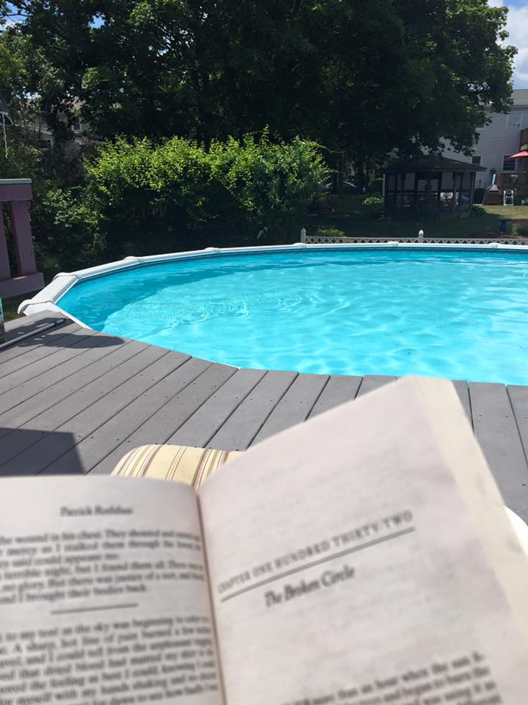
You ARE required to choose a project off of the provided list.

You are NOT required to choose a book off of the provided list.

Your book choice is entirely up to you.

Grading:

This assignment will be due during the week of 9/11/17.

It will be 10% of the marking period 1 grade for grades 10-12.

Your work will be evaluated using the following rubric:

 | 4 | 3 | 2 | 1
Critical Thinking | Very insightful using select details | Thoughtful and detailed | Some insights offered with limited detail | Exhibits only a basic understanding / lacks details
Organization | Highly organized and focused | Organized with appropriate structure | Formulaic / limited organization | Disorganized / unclear focus
Creativity | Outstanding creativity and originality | Creative and original | Limited creativity and effort | Unoriginal / imitative

Project Options:

- Argument Essay
- persuade your reader to support a position you have taken on your reading.

- Literary Criticism
- analyze the craft or style of your book selection.

- Journaling
- compose a collection of informal writing pieces throughout your reading process that share your reflections on the book and its relevance to your life.

- Letter to the author
- address the author to express ideas from your reading experience.

- Character Interview (dialogue)
- record a conversation between you and a character(s) or extend your writing into a screenplay.

- Poster
- design an original visual representation of your learning (and include a brief explanation of your artistic choices).

- Social Media Posts
- post online to share your reading experience with friends (and collect your posts via screenshots to email to your future English teacher).

- Dramatic presentation
- use your creative talents to prepare a performance for your classmates based on your reading experience (acting, dance, video, poetry, etc.).

- Storyboard Creation
- create a visual chart documenting the key ideas from your reading.

- “Write-like” Style Imitation / Narrative Extension
- add a segment to the text(s) you read by imitating your author’s writing style (ex. write an alternative ending).

- Scrapbook
- create a digital or paper scrapbook from the perspective of one of the main characters.

Summer Reading Book Suggestions - Grades 9 and 10

Romance
- The Fault in Our Stars by John Green
- Eleanor and Park by Rainbow Rowell
- All the Bright Places by Jennifer Niven
- If I Stay by Gayle Forman
- The Distance Between Us by Reyna Grande
- Everything Everything by Nicola Yoon
- The Beginning of Everything by Robyn Schneider
- Everything Leads to You by Nina LaCour
- I’ll Give You The Sun by Jandy Nelson
- Life in Outer Space by Melissa Keil

Science Fiction/Fantasy
- The Harry Potter Series by J.K. Rowling
- The Hobbit by J.R.R Tolkien
- A Darker Shade of Magic by V.E. Schwab
- Splintered by A.G. Howard
- The Rest of Just Live Here by Patrick Ness
- The Golden Compass by Philip Pullman
- The Fifth Wave by Rick Yancey
- Ender’s Game by Orson Scott Card
- Life as We Knew It by Susan Beth Pfeffer
- City of Bones by Cassandra Clare

Social Justice
- To Kill A Mockingbird by Harper Lee
- Wicked by Gregory Maguire
- Brave New World by Aldous Huxley
- The Help by Kathryn Stockett
- Animal Farm by George Orwell
- The Book Thief by Marcus Zusak
- Night by Elie Wiesel
- The Secret Life of Bees by Sue Monk Kidd
- The Curious Incident of the Dog in the Nighttime by Mark Haddon

Graphic Novel
- Nimona by Noelle Stevenson
- This One Summer by Mariko Tamaki
- American Born Chinese by Gene Luen Yang
- Blankets by Craig Thompson
- Legend: The Graphic Novel by Marie Lu
- Ms. Marvel, Vol. 1: No Normal by G. Willow Wilson
- Frankenstein by Gris Grimly
- In Real Life: Cory Doctorow and Jen Wang
- Wolf Children: Ame and Yuki by Mamoru Hosoda
- The Undertaking of Lily Chen by Danica Novgorodoff

Mystery/Suspense
- Under the Dome by Stephen King
- Pretty Baby by Mary Kubica
- Sherlock Holmes by Arthur Conan Doyle
- Finding Jake by Bryan Reardon
- The Girl on the Train by Paula Hawkins
- Paper Towns by John Green
- Thirteen Reasons Why by Jay Asher
- Miss Peregrine’s Home for Peculiar Children by Ransom Riggs
- The Westing Game by Ellen Raskin

Classic Teen
- Catcher in the Rye by J.D. Salinger
- The Outsiders by S.E. Hinton
- Pride and Prejudice by Jane Austen
- Little Women by Luisa May Alcott
- Jane Eyre by Charlotte Bronte
- I Know Why the Caged Bird Sings by Maya Angelou
- The Bell Jar by Sylvia Plath

Summer Reading Book Suggestions - Grades 11 and 12

Science Fiction/Fantasy
- The Name of the Wind by Patrick Rothfuss
- American Gods by Neil Gaiman
- The Lord of the Rings by J.R.R Tolkien
- Discworld by Terry Pratchett
- Neverwhere by Neil Gaiman
- Sister Sister by Sue Fortin
- The Legacy of Lucy Harte by Emma Heatherington
- Those who Lie by Diane Jeffery
- Strangers by Paul Finch
- The Girl who Lied by Sue Fortin

Social Justice
- Flowers for Algernon by Daniel Keyes
- Go Set a Watchman by Harper Lee
- The Grapes of Wrath by John Steinbeck
- Invisible Man by Ralph Ellison

Graphic Novel
- The Watchmen by Alan Moore
- Bone by Jeff Smith
- Scott Pilgrim by Bryan Lee O’Malley
- Monster by Walter Dean Myers
- The Alchemist by Paolo Coelho
- Redwall by Brian Jacques
- Batman: The Dark Knight Returns by Frank Miller
- Understanding Comics by Scott McCloud
- Maus by Art Speigelman

Classic Lit
- Catch 22 by Joseph Heller
- A Clockwork Orange by Anthony Burgess
- The Sun Also Rises by Ernest Hemingway
- A Farewell to Arms by Ernest Hemingway
- McTeague by Frank Norris
- Flight Behavior by Barbara Kingsolver
- Mermaids in Paradise by Lydia Millet
- The Blind Assassin by Margaret Atwood
- The Color Purple by Alice Walker
- Their Eyes Were Watching God by Zora Neale Hurston
- The Bluest Eye by Toni Morrison
- La Rose by Louise Erdrich
- The Nest by Cynthia D’Aprix Sweeney

Nonfiction
- The Omnivore's Dilemma by Michael Pollan
- 1776 by David McCullough
- The Tipping Point by Malcolm Gladwell
- Outliers by Malcolm Gladwell
- Just Mercy by Bryan Stevenson
- The New Jim Crow by michelle Alexander
- Justice by Dominick Dunne
- The Noble Hustle by Colson Whitehead
- My Lovely Wife in the Psych Ward : A Memoir by Mark Lukach
- Priestdaddy: A Memoir by Patricia Lockwood
- The Awkward Thoughts of W. Kamu Bell by Kamu Bell
- Born a Crime: Stories from a South African Childhood by Trevor Noah
- The Most Beautiful Life: My Life with Prince by Mayte Garcia

